BOOKSHOP SQL PROJECT
By Astha Gautam

PROJECT OVERVIEW
This project uses SQL Server to explore a bookshop database. It includes basic and advanced SQL queries for books, customers, orders, genres, sales, revenue, and remaining stock.

TOOLS USED
=========
- Microsoft SQL Server
- SQL (T-SQL)
- GitHub for project documentation and version control

DATABASE SETUP
QUERY:
Create Database bookshop
Use bookshop

-------------------------------------------------------

BASIC QUERIES
=============
QUESTION 1: RETRIEVE ALL BOOKS IN THE "FICTION" GENRE
QUERY:
Select Count(*) as fiction
From Books

Where genre='fiction'

-------------------------------------------------------
RESULT:
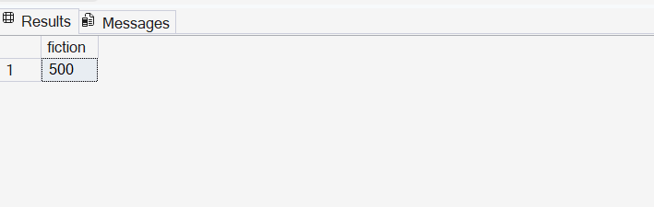

QUESTION 2: FIND BOOKS PUBLISHED AFTER THE YEAR 1950
QUERY:
Select *
From books
Where Published_Year >1950
-------------------------------------------------------
RESULT:
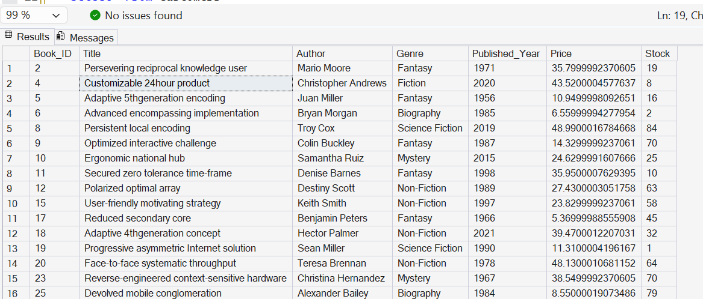

QUESTION 3: LIST ALL CUSTOMERS FROM CANADA
==========================================
QUERY:

Select *From Customers
Where country='Canada'
-------------------------------------------------------
RESULT:
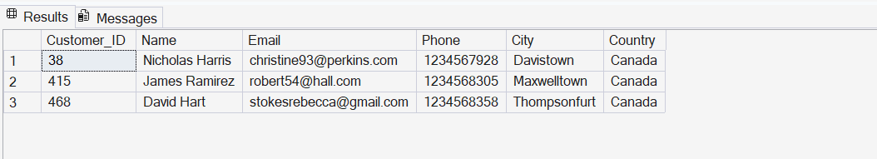

QUESTION 4: SHOW ORDERS PLACED IN NOVEMBER 2023
QUERY:
Select *From Orders
Where year(order_date) =2023 and month(order_date)=11;
-----------------------------------------------------
RESULT:
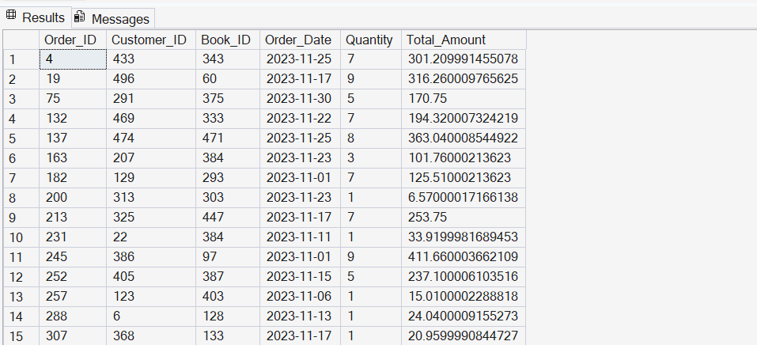

QUESTION 5: RETRIEVE THE TOTAL STOCK OF BOOKS AVAILABLE
QUERY:
Select Sum(stock)as total_books
From books
-------------------------------------------------------
RESULT:
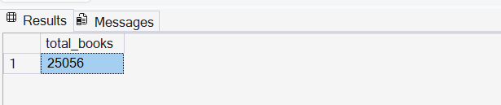

QUESTION 6: FIND THE DETAILS OF THE MOST EXPENSIVE BOOK
=======================================================
QUERY:
SELECT*FROM BOOKS
WHERE PRICE=(SELECT MAX(PRICE)FROM BOOKS)
-------------------------------------------------------
RESULT:
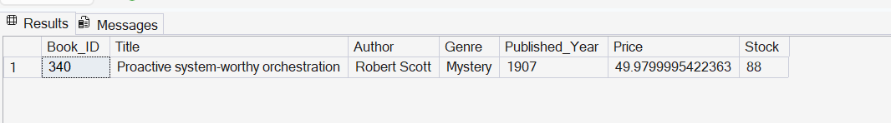
QUESTION 7: SHOW ALL CUSTOMERS WHO ORDERED MORE THAN 1 QUANTITY OF A BOOK
QUERY
Select*From Orders
Where quantity >1
---------------------------------------------------
RESULT:
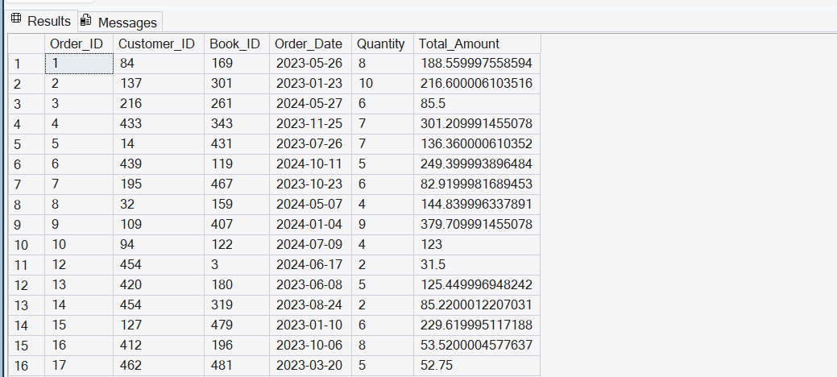

QUESTION 8: Retrieve all orders where the total amount exceeds $20
QUERY
Select*From Orders
Where total_amount>20
----------------------------------------------------------------
RESULT
QUESTION 9: LIST ALL GENRES AVAILABLE IN THE BOOKS TABLE
QUERY
Select Distinct genre From books
-----------------------------------------------------------------------
RESULT

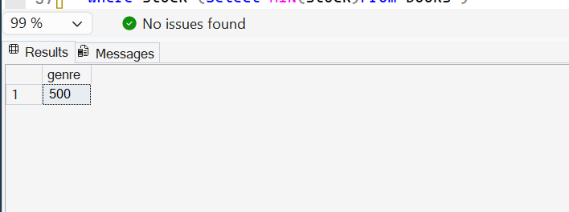
QUESTION 10: FIND THE BOOK WITH THE LOWEST STOCK
QUERY:
SELECT TOP 1*
FROM BOOKS
Order by stock ASC;

------------------------------------------------------
RESULT:
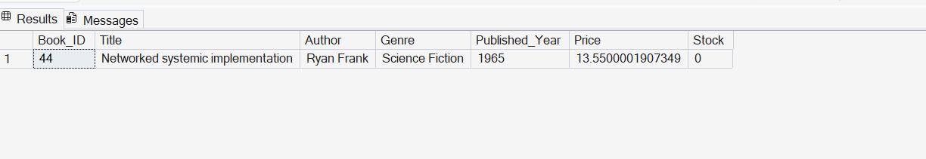
QUESTION 11: CALCULATE THE TOTAL REVENUE GENERATED FROM ALL ORDERS
QUERY:
Select SUM(Total_Amount) AS TOTAL_REVENUE
FROM Orders
-------------------------------------------------------
RESULT:
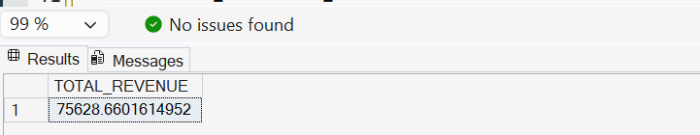
ADVANCE QUERIES
QUESTION 1: RETRIEVE THE TOTAL NUMBER OF BOOKS SOLD FOR EACH GENRE
QUERY:
Select b.genre ,Sum(o.quantity)as total_order_books
From Orders o
join books b
On b.book_id=o.book_id
Group By b.genre
------------------------------------------------------
RESULT:
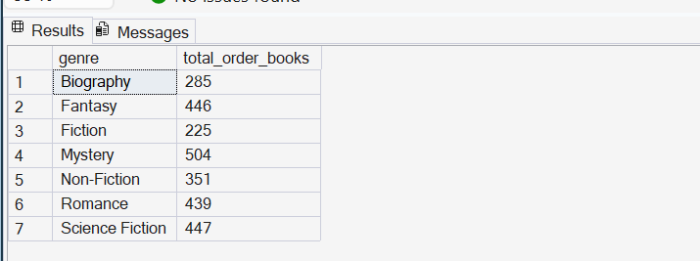

QUESTION 2: FIND THE AVERAGE PRICE OF BOOKS IN THE "FANTASY" GENRE
QUERY:
Select avg(price)as average_price
From Books
Where genre='fantasy'

RESULT:
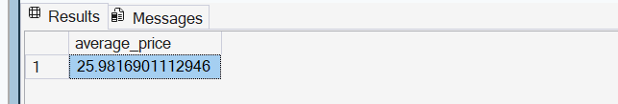

QUESTION 3: LIST CUSTOMERS WHO HAVE PLACED AT LEAST 2 ORDERS

QUERY:
Select O.customer_id,C.name,count(O.ORDER_ID)AS ORDER_COUNT
FROM ORDERS O
JOIN Customers C
ON C.CUSTOMER_ID=O.CUSTOMER_ID
GROUP BY O.CUSTOMER_ID,C.NAME
HAVING COUNT(ORDER_ID)>=2
-------------------------------------------------------
RESULT:
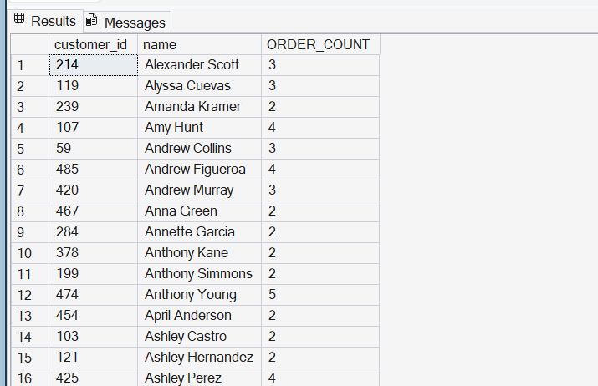

QUESTION 4: FIND THE MOST FREQUENTLY ORDERED BOOK
QUERY:
SELECT
TOP 2
O.BOOK_ID,B.TITLE,COUNT(O.ORDER_ID)AS ORDER_COUNT
FROM Orders O
JOIN BOOKS B
ON O.BOOK_ID=B.BOOK_ID
GROUP BY B.Title,O.BOOK_ID
ORDER BY ORDER_COUNT DESC
-------------------------------------------------------
RESULT:
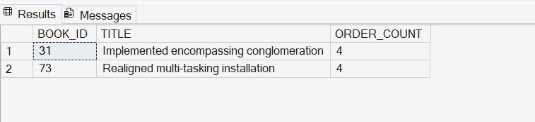

QUESTION 5: SHOW THE TOP 3 MOST EXPENSIVE BOOKS OF THE "FANTASY" GENRE
QUERY:
SELECT TOP 3 *FROM BOOKS
WHERE GENRE='FANTASY'
ORDER BY PRICE DESC

------------------------------------------------------
RESULT:
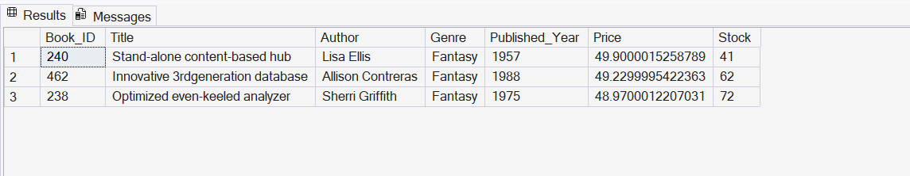

QUESTION 6: RETRIEVE THE TOTAL QUANTITY OF BOOKS SOLD BY EACH AUTHOR
QUERY:
Select
B.AUTHOR,SUM(O.QUANTITY)AS TOTAL_BOOK_SOLD
FROM ORDERS O
JOIN BOOKS B
ON B.BOOK_ID=O.BOOK_ID
GROUP BY B.AUTHOR,O.BOOK_ID
-------------------------------------------------------
RESULT:
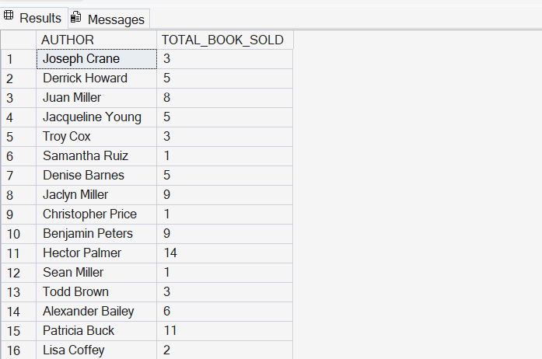

QUESTION 7: LIST THE CITIES WHERE CUSTOMERS WHO SPENT OVER $30 ARE LOCATED
QUERY:
Select Distinct c.city,total_amount
From orders o
join customers c
On o.customer_id= c.customer_id
Where o.total_amount>30
-------------------------------------------------------
RESULT:
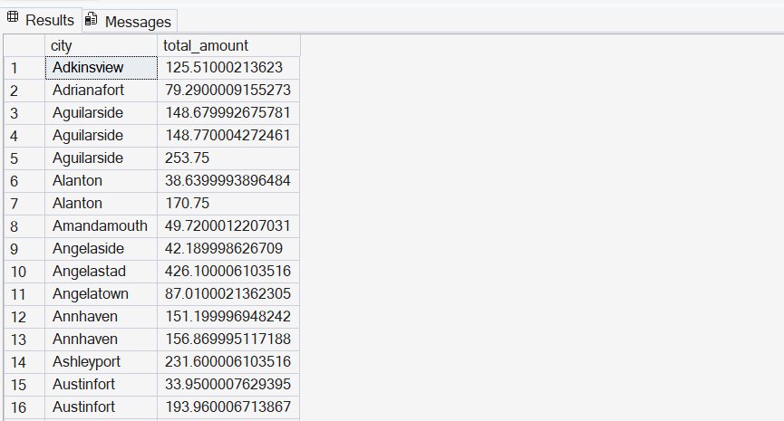

QUESTION 8: FIND THE CUSTOMER WHO SPENT THE MOST ON ORDERS
QUERY:
Select Top 10
c.customer_id,c.name,sum(o.total_amount) as total_spent
From orders o
join customers c
On c.customer_id=o.customer_id
Group by c.customer_id,c.name
Order by total_spent Desc
-------------------------------------------------------
RESULT:
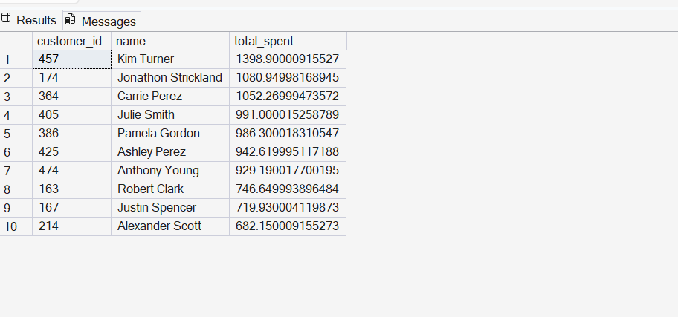
> This query shows the top 10 customers by total spending. To return only the single highest-spending customer, change `TOP 10` to `TOP 1`.

-------------------------------------------------------

QUESTION 9: CALCULATE THE STOCK REMAINING AFTER FULFILLING ALL ORDERS
QUERY:
Select b.book_id,b.title,b.stock,coalesce(sum(o.quantity),0)as order_quantity,
b.stock-coalesce(sum(o.quantity),0)as remaining_quantity
From books b
left join orders o
On b.book_id=o.book_id
Group By b.book_id ,b.title,b.stock
Order By b.book_id;

-------------------------------------------------------

RESULT:
